MSc Artificial Intelligence & Machine Learning (MSAIML)
Paper: Data Structures and Algorithms
Scenario-Based Practical Assessment: Hashing
Reg No: 2648555

The Scenario: RailSwift Instant PNR Lookup
RailSwift is a start-up that runs ticket-booking counters at a busy railway junction. During festival season, counter agents must retrieve a passenger's booking within milliseconds using the 10-digit PNR (Passenger Name Record) number. The current system stores bookings in an unsorted list and performs a linear search, so lookups slow down sharply as bookings grow, and queues at the counter are getting longer.
You have been hired as a junior engineer to build the core lookup engine as a hash table. Each booking record contains:
- PNR — 10-digit integer key (e.g. 8203416572); must be unique
- Passenger Name — string
- Train Number — 5-digit integer
- Status — CONFIRMED / RAC / WAITLIST
Because the server has limited memory, the engineering lead wants the table to start small and grow only when necessary. Cancelled tickets must be removed without breaking the lookup of other bookings.

Tasks

Task 1 — Hash Table Design (Open Addressing)
- Initial table size m = 11 (a prime number).
- Primary hash function: h(k) = k mod m
- Collision resolution: Linear Probing — h(k, i) = (h(k) + i) mod m, for i = 0, 1, 2, …
- Each slot must be in one of three states: EMPTY, OCCUPIED or DELETED (tombstone).

Task 2 — Core Operations
- insert(record) — place the record using linear probing; report the home index, final index and number of probes.
- search(pnr) — return the full record or 'Not Found'; report the number of probes.
- delete(pnr) — cancel a booking by marking its slot as DELETED (not EMPTY). Explain why in comments.
- display() — print every slot with its index, state and PNR.
- loadFactor() — return α = n / m, where n is the number of OCCUPIED slots.

Task 3 — Dynamic Resizing (Rehashing)
After every successful insertion, if the load factor α exceeds 0.7, the table must be rehashed: create a new table whose size is the smallest prime ≥ 2m, and re-insert every OCCUPIED record (tombstones are discarded). Print the table before and after rehashing.

Task 4 — Boundary Conditions (must be handled gracefully)
# | Condition | Expected Behaviour
B1 | Insert a PNR that already exists | Reject with message 'Duplicate PNR' (or update the record — state your choice)
B2 | Search / delete on an empty table | Message 'Table is empty'; no crash
B3 | Delete a PNR that does not exist | Message 'PNR not found'
B4 | Invalid PNR (not 10 digits, negative, non-numeric) | Reject input with a validation message
B5 | Search for a key that sits beyond a DELETED slot in its probe sequence | Must still be found (probing continues past tombstones)
B6 | Insert when a DELETED slot is in the probe path | Re-use the tombstone slot only after confirming the key is not a duplicate
B7 | Table full (when rehashing is switched off) | Message 'Hash table overflow'; probing must not loop forever

Task 5 — Demonstration Test Data
Insert the following bookings in the given order into an empty table of size 11:
# | PNR | Passenger | Train No. | Status
1 | 8203416572 | Ananya Rao | 12627 | CONFIRMED
2 | 8203416583 | Rahul Menon | 12627 | RAC
3 | 8203416540 | Fatima Sheikh | 16526 | CONFIRMED
4 | 8203416599 | Vikram Iyer | 12008 | WAITLIST
5 | 8203416615 | Divya Nair | 12627 | CONFIRMED
6 | 8203416561 | Arjun Patil | 16526 | RAC
7 | 8203416604 | Sneha Kulkarni | 12008 | CONFIRMED
8 | 8203416626 | Karthik Gowda | 12627 | WAITLIST

Then perform the following sequence and show the output of each step:
- After insertion #7, display the table and the load factor.
- Delete PNR 8203416583 (Rahul Menon cancels his ticket).
- Search PNR 8203416561. It must be found — explain how many probes were needed and why.
- Search PNR 8203416583. It must return 'Not Found'.
- Insert record #8 (8203416626). Observe whether the tombstone is reused and whether rehashing is triggered.
- Demonstrate each boundary condition B1–B7 with at least one input.

Task 6 — Analysis (write in your report)
- Which keys collided and why? What is primary clustering, and where do you see it in your table?
- Compare the average number of probes for successful search before and after rehashing.
- State the time complexity of insert, search and delete in the best, average and worst case.

Self-Learning Extensions (choose at least one)
Marks under Self-Learning are awarded for genuine exploration beyond the basic implementation. Suggested directions:
- Alternative collision strategies: implement Quadratic Probing, Double Hashing with h₂(k) = 7 − (k mod 7), or Separate Chaining, and compare the average probe count on the same data.
- String hashing: allow lookup by passenger name using a polynomial rolling hash, and discuss how you chose the base and modulus.
- Performance experiment: insert 10,000 random PNRs, plot average probes against load factor (0.1 to 0.9) for linear probing vs. chaining, and compare with the theoretical expectations.
- AI/ML connection: demonstrate the hashing trick (feature hashing) for converting text into fixed-length vectors, or explain how MinHash / Locality-Sensitive Hashing finds near-duplicate documents.
- Benchmarking: compare your implementation's lookup time with the language's built-in dictionary/HashMap and explain the difference.

Deliverables
- Source code with meaningful comments.
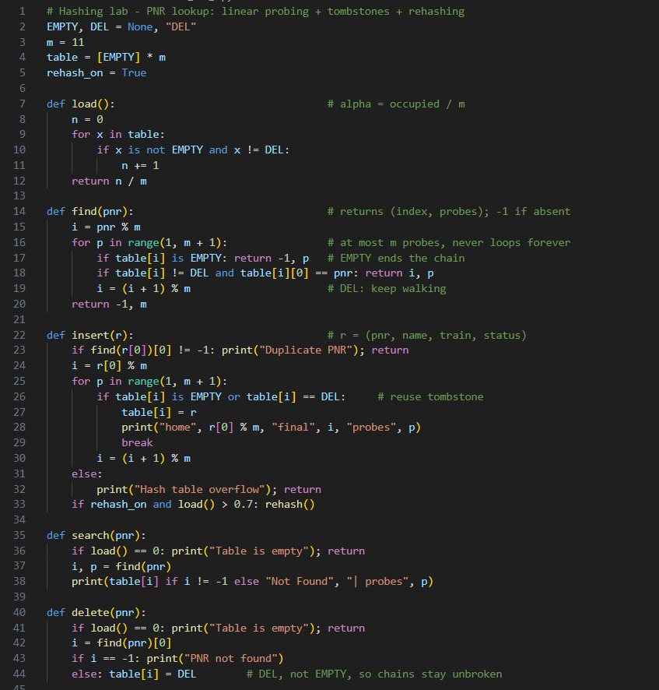
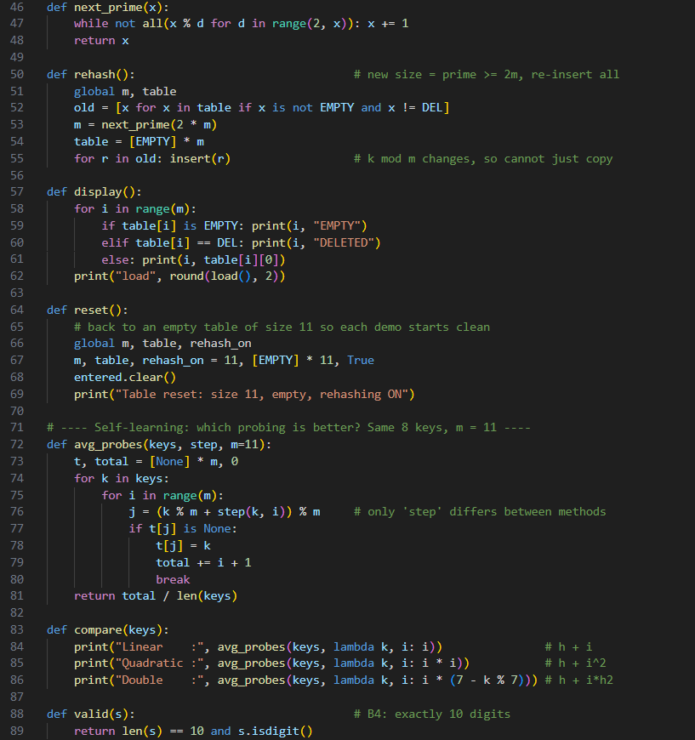

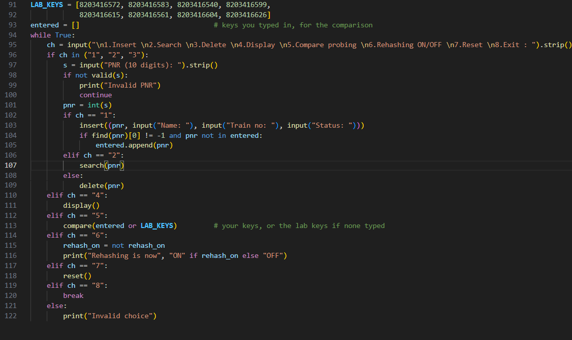

- Screenshots or console output for every step in Task 5.
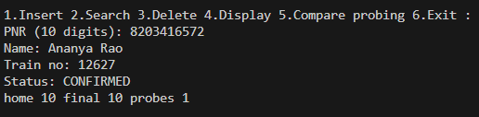
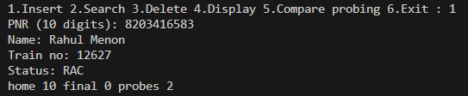
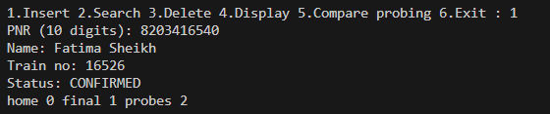
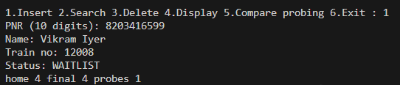
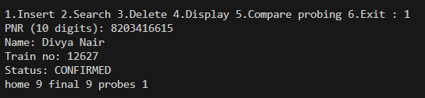
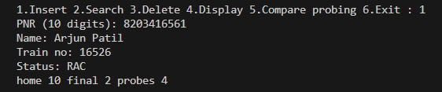
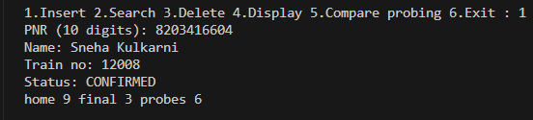
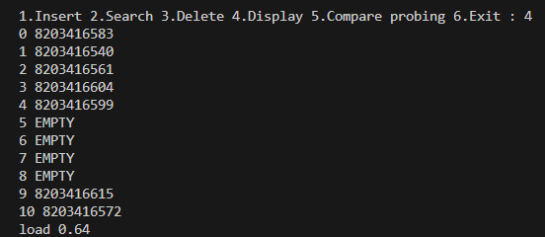
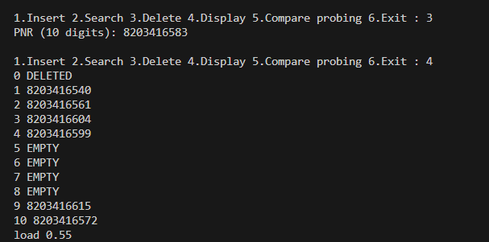
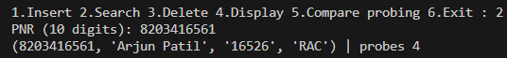
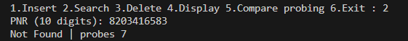
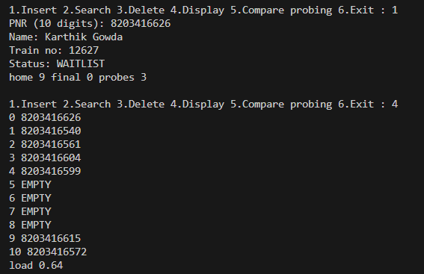

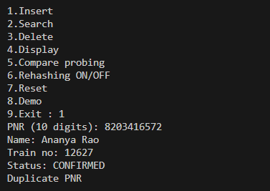
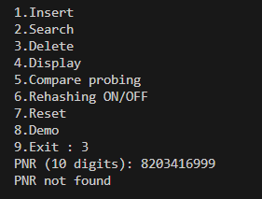
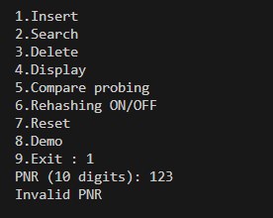

Self - Learning Component Output:
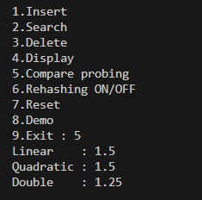

- A short report (2–3 pages) covering Task 6 and your self-learning extension.

1. Which keys collided, and why? What is primary clustering?
Each key's home slot is PNR mod 11:
Home slot | Keys that landed there
10 | 8203416572, 8203416583, 8203416561
9 | 8203416615, 8203416604, 8203416626
0 | 8203416540, which didn't collide with another key's home but with 583, which had spilled over from slot 10
4 | 8203416599 (no collision)
Why they collided: keys that differ by a multiple of 11 have the same remainder. 572 and 583 differ by 11, and 615, 626 and 604 differ by 11 or 22. A set of nearby PNRs is exactly this situation. Also, 8 keys are going into only 11 slots, so some sharing is almost certain.
Primary clustering is when occupied slots form a long unbroken run, so any key that hashes into the run has to walk to its end, and then makes the run longer. In the table after insertion #7, slots 9, 10, 0, 1, 2, 3, 4 form one continuous block of 7 slots (wrapping round the end). That's why key 604 needed 6 probes, and 626 would need 8 if nothing had been deleted. This is the evidence for your viva question on why 626 needed so many probes.

2. Average probes for a successful search, before and after rehashing
Table | Probes per key | Average
m = 11 (all 8 keys, no deletion) | 1, 2, 2, 1, 1, 4, 6, 8 | 3.125
m = 23 (after rehash) | all 1 | 1.0
What changed: the homes become PNR mod 23: 17, 5, 8, 21, 14, 6, 3, 2. All eight are different, so there are no collisions and no cluster. This is also why all keys must be re-inserted instead of copying the array: the home slot depends on m, so it changes when m changes.
A note on the demo: in the Task 5 sequence record #8 (626) takes 3 probes instead of 8, because the tombstone left by Rahul's deletion at slot 0 is reused. That's an answer to "was the tombstone reused?" (yes), and rehashing was not triggered there, since the load stays at 7/11 = 0.636.

3. Time complexity
Operation | Best | Average | Worst
Insert | O(1) | O(1) | O(n)
Search | O(1) | O(1) | O(n)
Delete | O(1) | O(1) | O(n)
- Best: the key is in its home slot, one probe.
- Average: this holds while the load factor is kept low. For linear probing, the expected probes are about ½(1 + 1/(1−α)) for a successful search, which is 2.17 at α = 0.7, and ½(1 + 1/(1−α)²) for an unsuccessful one, which is 6.06 at α = 0.7.
- Worst: every key sits in one huge cluster, or the table is nearly full, so a search walks through up to n slots.
- Why rehash at 0.7: clustering makes probes grow sharply as α approaches 1. Chaining can tolerate α > 1 because a full bucket just gets a longer list.
- Rehashing cost: O(n) for one rehash, but because the table doubles each time, it's O(1) amortized per insert.

4. Self-learning extension
All probing methods are the same loop. Only the jump changes, and the table below comes from the same 8 keys at m = 11:
Method | Jump on try i | Avg probes
Linear probing | i | 3.125
Quadratic probing | i² | 2.125
Double hashing | i × (7 − k mod 7) | 2.375
Conclusion: both alternatives spread keys out, so they reduce primary clustering. Quadratic probing can fail to find a free slot once the table is more than half full, and double hashing costs a second hash.
Real-world uses:
- Database indexes and caches use hash tables.
- Password storage uses cryptographic hashes such as SHA-256, which are one-way and collision-resistant, unlike a lookup hash.
- In ML, the hashing trick turns words into fixed-length vectors, and MinHash/LSH finds near-duplicate documents.

